Docker : Docker is an open source platform which help to create containerization application. Using docker we can build and ship the application with help of image to deploy on different machine.

Docker also known as Adv virtualization.

Virtualization

If we want to run any application software we need system software OS. Window, Linux, Unix or Mac.

In one machine we can run multi OS.

Limitation of we can only one OS at time.

VW ware software

Oracle virtual box.

Running the OS with help of VM ware software is known virtualization.

Virtualization running the OS in abstract mode. Virtualization support abstract version of an OS.

If my base machine contains 16 RAM 1TG hard disk.

In Virtualization we need to share resources to guest OS or VM OS.

Like RAM or external memory

In Containerization we are creating abstract version of an application.

If we want to run any application like c or c++ or java or python in my machine I need run time environment for that application.

Using docker with help of Docker image, we can run the application without installing or with run time environment we can run the application.

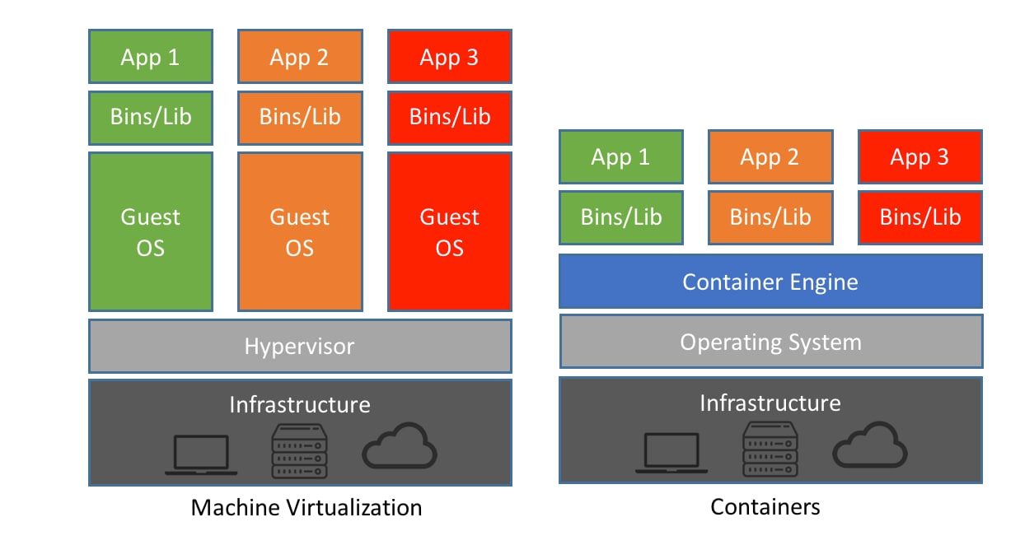

Docker commands

Check the version of the docker

docker --version

docker images : docker images is read only template file which is responsible to run the application with help of docker container.

docker images this command is use to check all images present in local or VM machine or lab machine.

docker pull imageName

example

docker pull hello-world this command is use to pull the image.

docker run imageName/imageId

docker run hello-world this command is use to run the image in our machine.